**User Research Outcomes**

**LAB SHEET 4**

**D.I.K. Rajapakshe | IT16178700**

**SE3050 - UEE**



**Health Care App**

**Task 4 :- Wireframe 1**

**User comments**

* Showing lengthy list of details if the user typed much details in notes. So, hard to identify the quickly noted which added in previously.
* Users can’t find the way how to add notes in very first.
* Save, edit icons are hard to find and no validation So, user press the back-button loss every data typed in first which unsaved
* Mismatch color matching having white color background and notes list background.

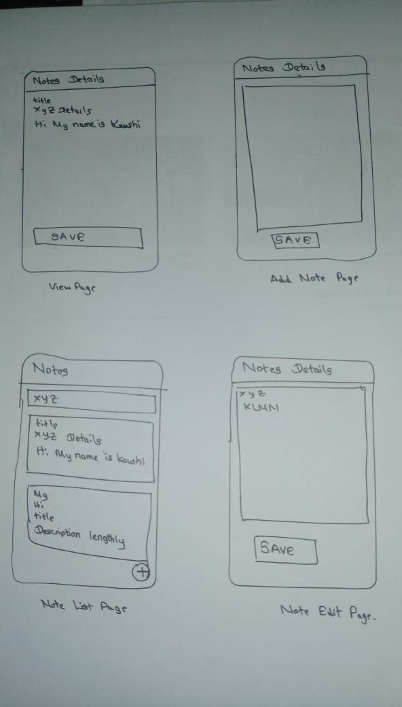

**Wireframe 2**

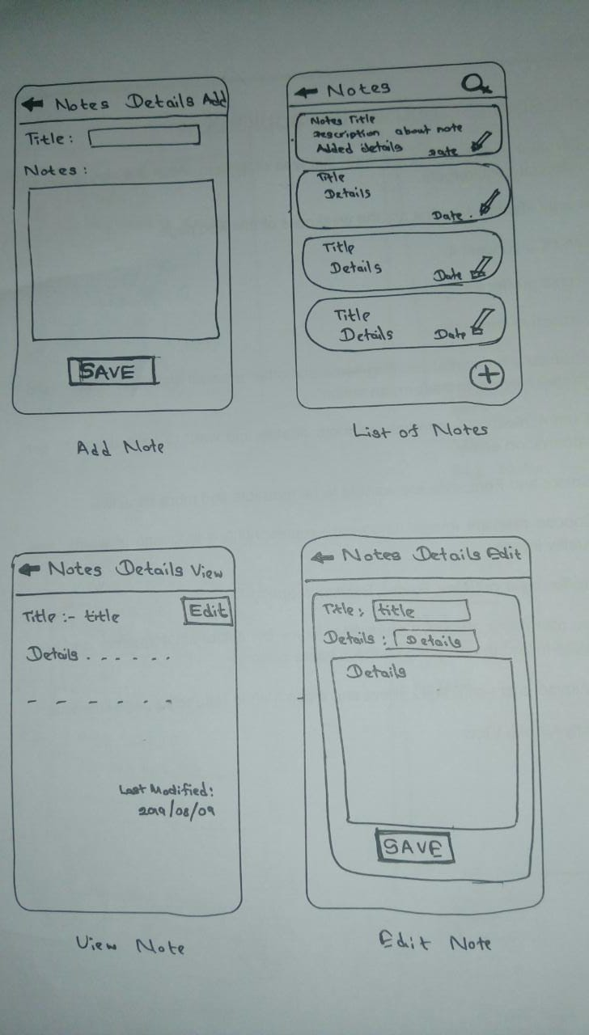

User comments

* There is back button to go to previous page.
* Save, edit buttons are easy to find.
* Customer can see the note title name and modified date on the list.
* Customer can easily identify the items on the list and can search the notes.

**Task 4 :- Adobe XD design**

• Considering both wireframes the wireframe 2 is best for the function because of the user comfortable design and easy usability.

